WALO 2

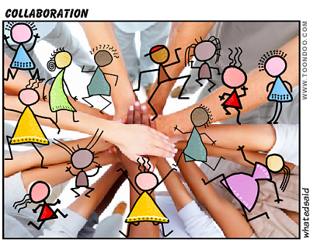
People talk a great deal about 4 C’s (collaboration, communication, critical thinking, and creativity) of 21st century skills. As a teacher, I have wanted to practise these skills on a regular basis .My second walo was collaborating with Poorvi, (head of mathematics department) to introduce IB curriculum for the new batch of students. The session aimed to create an understanding of IB learner profile, the philosophy of integration, which binds all the aspects of the programme. The session would provide an overview of the subject structure, the views of senior students with regard to learning approach, the difference in philosophy and practice between the national and IB curricula.
Having, read the book “The Power of Protocols” I have been wanting to practice each of these protocols in my classroom and with my colleagues .As the introductory session with the students approached ,the thought of conducting this session differently prevailed in my mind . I decided to practice- The protocol SIP- Standards in Practice Protocol –Page 84 in my WALO. The SIP protocol helps to assess whether a learning activity prompts students to meet a particular standard, and then modify that activity accordingly. SIP can be used for teachers who teach the same students and meet on a regular basis. I found SIP to be a great planning tool, which would help me to grow further as an educator. I grabbed this opportunity to practice this protocol and started thinking about how I could implement this in my new IBDP classroom.
The thought came within a fraction of seconds that if we could collaborate and introduce our subjects together. As we started our discussion, things slowly started falling in place. Then the biggest question was how we create time to plan this session in our extremely busy schedule. We thought of including the senior students who had just finished with their exams and share their experience with the new batch. The students joined enthusiastically. It was an overwhelming experience as a teacher to see how these students had grown up in the passage of two years into mature individuals. Due to time constraints we planned the session while walking down together to the bus after school time, during tea or lunch breaks as it was difficult for us have a free lecture at the same time.
- The senior students were divided into four groups.
- Each of the groups was given responsibilities from the following list of tasks to choose from.
1 .Video shooting of the session.
2. Typing the questionnaire.
3 .Preparing slides.
4. Correction of paper.
5. Printouts of the puzzle.
6.Photographs
We had to reschedule our classes, as we are shared resources between the national and the international sections. Poorvi and I struggled with adjusting our classes, as we had to be relieved together for one and a half hours for conducting the session. . All the arrangements were made in the chemistry laboratory.
We wanted to follow a systematic process, a set of tools and strategies to help us improve the teaching and learning of chemistry and mathematics. Through the considerations of key ideas and practices, improve the understanding of chemistry and mathematics content, clarify curriculum , identify potential learning difficulties or misconceptions .This would help us to bridge the gap between standards and Practice, our ability as a teacher to analyse and diagnose student thinking based on their written work. The feedback would provide us the methodology, effective teaching strategies, and improve the coherence of the subject. The group comprised of 25 students.
We roughly chalked out an outline of the steps we would follow. After a lot of brainstorming, we decided to follow the following steps
9.45 am to 11.15 am session….Introduction of chemistry programme to new group of IB students.
Teacher introduction (5 minutes each) Here we would talk about our experience in teaching National board and why we enjoy teaching the IB curriculum. What is the difference between the two curriculums and the reach of both.
Student Introduction … (10 minutes) Students will be asked to introduce themselves and name a metal which fascinates them and why? In a similar way, connect themselves with a number which fascinates them and why?
Activity ---------puzzle that would, collaborate the two subjects. (20 minutes)
Overview of the subject structure-Discuss the chemistry paper style and assessment patterns, extended essay (15 minutes)
Invite seniors who have given exam in November 2012 to discuss their experience with the IB curriculum (10 minutes)
Diagnostic test 15 questions in each subject (30 minutes)
Reflection…Ask the students to write three things, which come to their mind after the session.
The session started at 9.45. We introduced ourselves and followed the protocol. The session went on smoothly without any hindrances. We operated as a team. As I talked about the IB Curriculum, I felt like a lifelong learner. We functioned in partnership, taking charge of the session, assisting each other. The puzzle was to figure out a geometrical shape connecting the two subjects. The students were engrossed solving the puzzle. It taught them that they had to connect both the subjects in order to solve the puzzle. Through a fun activity the first lesson that the students learnt was-Learning is inter- disciplinary. The activity helped us to identify their background knowledge. The students were excited when we addressed them about the extended essay .This was a different experience for me, as our earlier orientations were subject focussed. We invited our colleague Siddharth, to attend the session and give us a feedback. Our IBDP leader, Parag Fatepuria also joined the session and was pleased about the initiative taken by us. Students’ reflections have helped me to understand their fears, strengths, and their needs. The session provided a qualitative indication of the students. They need a refresher course in chemistry, so that would be my first step with this group of students.

PHOTOGRAPHS OF THE PUZZLE
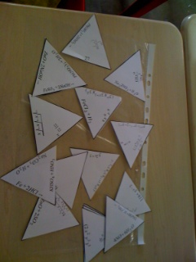
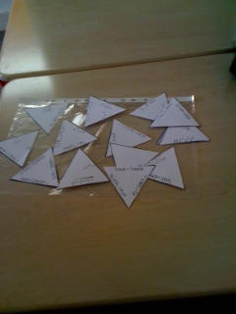

Siddharth’s feedback
- Session was well planned. Students felt comfortable, though they were interacting with the teachers for the first time.
- The students along with the way of learning and assessment understood the general idea about the IB curriculum for chemistry and mathematics.
(*) STUDENT REFLECTIONS
Student1:
Three things that came to my mind;
- I need to work upon my speed to complete tests on time.
- I seem to be confident about my Chemistry syllabus until date, as I have not studied it for 5 months since now.
- Arithmetic calculations (Operations) took me the greatest time since I am used to using calculators all the time. It seems have to work on mental maths.
Student2:
- Mathematics and Chemistry are interesting IB subjects.
- Chemistry concepts need to be reviewed due to a six month break.
- Looking forward to take both subjects at Higher Level.
Student3:
- This session was a brief up of what are next couple of years going to be – Enjoyment, Discoveries, Knowledge and HARDWORK?
- I got excited for Extended Essay and the Group – 4 projects.
- I have opted for [PCM – HL] and I just need to know whether it is manageable.
- I will take Maths, Chemistry [HL], if I am capable of it.
- Overall, it showed me the need to buck for the next two years.
My learning
- Build on each other’s ideas, share the teaching space and learn together.
- Be open to new ideas.
- Include students, and ask for feedback.
- Share. "Superstar" teachers working in isolation cannot produce the same results as teachers who share and develop professional practices together.
- Collaboration makes the learning and teaching richer. Collaboration among teachers can greatly enhance the effectiveness of instruction and the performance of students. Greater are the connections greater is the learning.
- Building such, a culture does not happen by chance; it must be structured, taught, learned, and practiced.
- I am learning to collaborate and collaborating to learn.
In my next session, I would like to conduct this session for the entire school, collaborating with all the colleagues and facilitate the process.
The video, the questions, Photographs, power point presentations of this session will be attached in my DP.

